1. Select eno, ename, salary from employee where salary > 4000

2. Combining conditions and Boolean operators

Removing duplicates

Range specification

String operation

**List all employee names with their project name**

SELECT employee.ename, projects.Pname

FROM employee, projects, work_in

where employee.eno = work_in.eno and work_in.Pno = projects.Pno

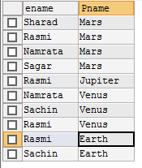

**List name of all employee and their salary who are working in project “Mars” or “Venus”**

SELECT employee.ename, employee.salary

FROM employee, projects, work_in

where employee.eno = work_in.eno and work_in.Pno = projects.Pno and projects.pname="Mars" || "Venus"

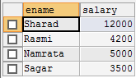

**List name of all employee and their salary who are working in project earth and venus**

SELECT employee.ename, employee.salary

FROM employee, projects, work_in

where employee.eno = work_in.eno and work_in.Pno = projects.Pno and projects.pname="Earth" && "Venus"



**List name and address of all employees who works in department which is located in pokhara**

SELECT employee.ename, employee.address

FROM employee, department

where employee.dep_no= department.dep_no and department.Location="pokhara"

